How to set-up an AWS security group for Jenkins

1. Click the link to the security group found in your EC2 instance information.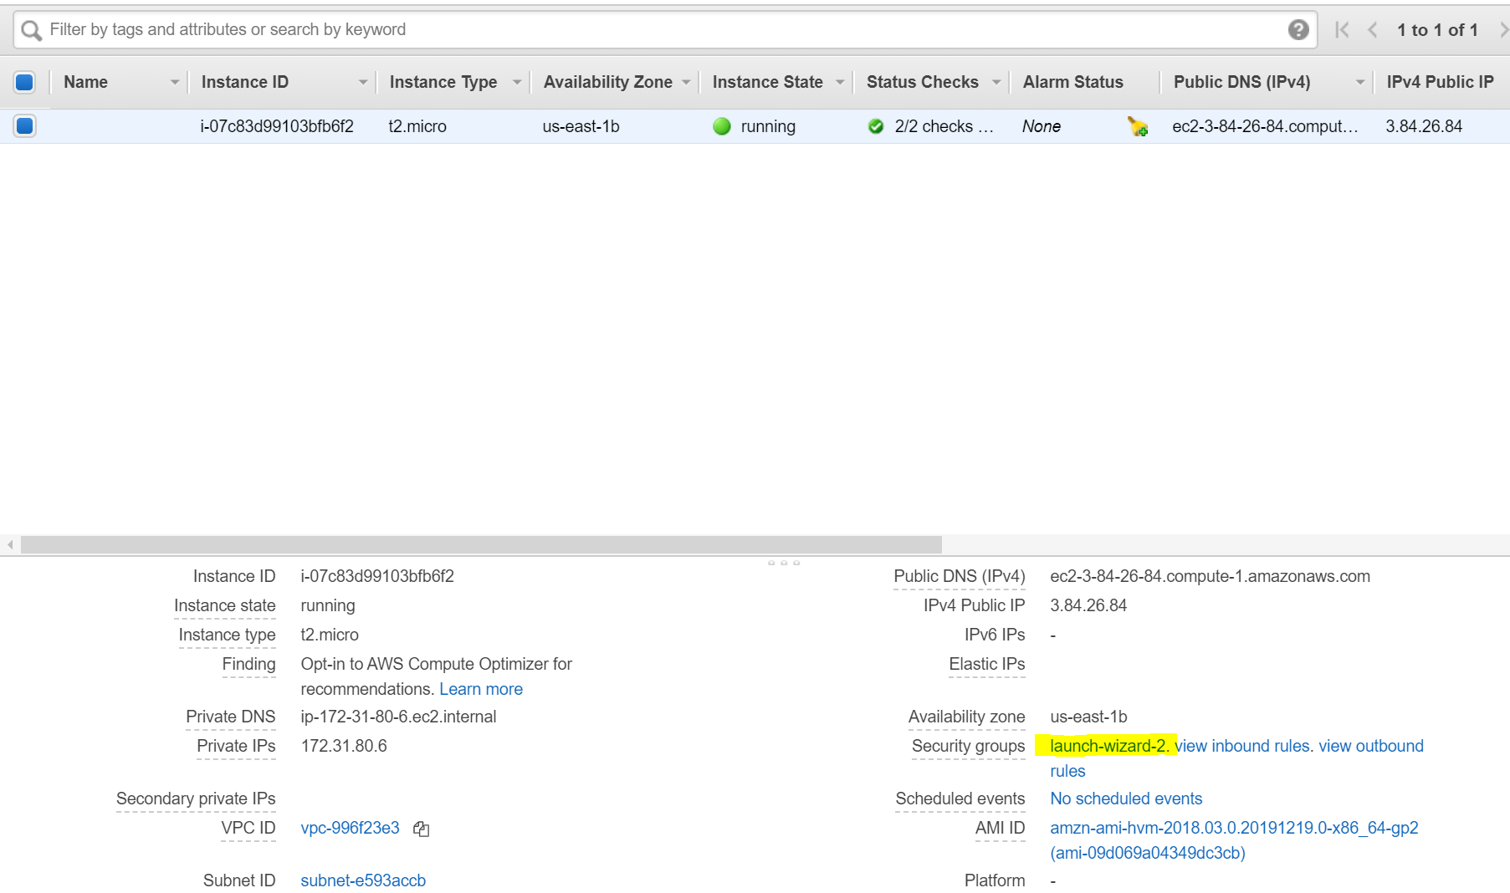
2. Select “Inbound” on the bottom of the window. You will see that only port 22 is configured. Select the Edit button to add additional ports. 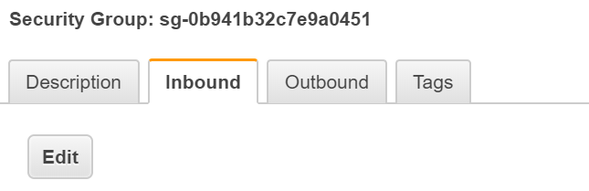
3. You will have to **add 3 new rules**. An HTTP Rule, A Custom TCP Rule, and a HTTPS Rule. Make sure the inbound rules and port range look like the screenshot below. **Save.**

